Samarth Rural Educational Institute’s

Samarth College of Computer Science, Belhe
Academic Year 2026-2027(SEM-V)

T.Y. B.Sc. (Information Technology)
Practical NO: 1
Title : Introduction to VB.NET

Roll NO: 65 Batch : C

SET A:

Q1: Write a C program to accept different types of data (int, float, char and string) and display it using I/O functions and appropriate format specifiers.

ANS:

Q2: Write a Vb.net program to accept two integer values from the user and display sum using WriteLine().

ANS: Module program
Sub main()
Dim a As Integer
Dim b As Integer
Dim c As Integer
Console.WriteLine("Enter First num : ")
a = Convert.ToInt16(Console.ReadLine())
Console.WriteLine("Enter Second num : ")
b = Convert.ToInt16(Console.ReadLine())
c = a + b
Console.WriteLine($"The sum of {a} & {b} is {c}")
End Sub
End Module
O/P:

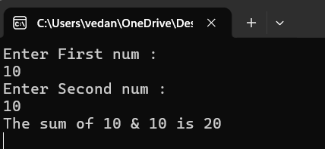

Q3: Write a Vb.net program to check given number is Even or Odd.

ANS: Module program
Sub main()
Console.WriteLine("Enter num : ")
Dim a As Integer = Console.ReadLine()
If a Mod 2 = 0 Then
Console.WriteLine("Number is even")
Else
Console.WriteLine("Number is odd")
End If
End Sub
End Module

O/P:
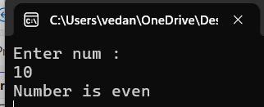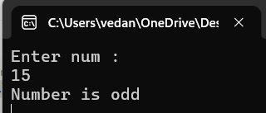

Q4: Write a Vb.net program to find factorial of a given number (Use a For loop to calculate its factorial).

ANS: Module program
Sub main()
Console.WriteLine("Enter num : ")
Dim a As Integer = Console.ReadLine()
Dim fact As Integer
fact = 1
For i As Integer = 1 To a
fact = fact * i
Next
Console.WriteLine($"Factorial of {a} is {fact}")
End Sub
End Module
O/P:
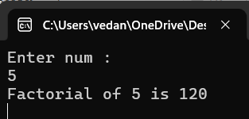

Q5: Write a Vb.net program to display all numbers between 1 and 100 that are divisible by 5.

ANS: Module program
Sub main()
For i As Integer = 1 To 100
If i Mod 5 = 0 Then
Console.WriteLine(i)
End If
Next
End Sub
End Module
O/P:
